### Name

Granger Causality Covid-19

### Description

We aim to comprehensively analyze the correlation between the impression of the US public on pandemic from April 2020 to August 2020 together with the proportion of news reports in the United States, China and South Korea, utilizing tools such as the correlation coefficient and Granger causality. The impressions include distress about spreading viruses, being kept in isolation, stressing about financial hardship and failing economics. We use the rationality of these results to compare the reality people are being faced with within the real world.

### Visuals (what you will see in this project)

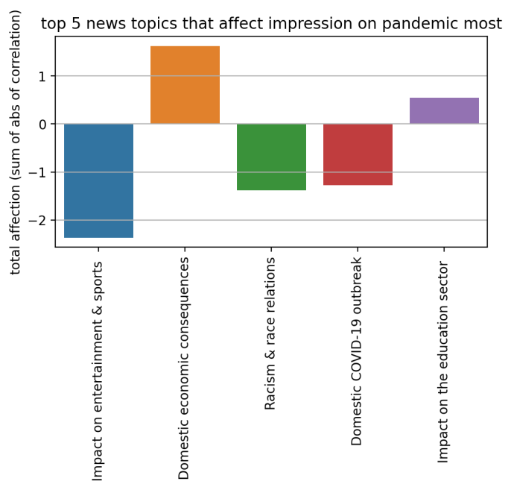

**Requirements**

1. master-conflux.zip
2. pip install pandas
3. pip install numpy
4. pip install matplotlib
5. pip install seaborn
6. python -m pip install --user numpy scipy matplotlib ipython jupyter pandas sympy nose

### Usage

In this project, we are given data about the proportion of news topics in different countries and the general impression of the pandemic in the US. Since there is a lot of missing and non -consecutive data, we cannot use interpolation to fill the NaN values. We decided to focus on the complete data gathered by certain countries, including China, Korea and the US’s news topics from April 4th to August 8th and public impressions from April 4th to August 8th. We use this data to compute both Spearman correlation coefficients and Granger Causality.

### Support

Please contact the contributors if you have any questions or concerns/issues.

### Contributors:

Ding Ma, [martin98@bu.edu](mailto:martin98@bu.edu)

Gordon Ng, [gng8@bu.edu](mailto:gng8@bu.edu)

Tegveer Ghura, [tegveerg@bu.edu](mailto:tegveerg@bu.edu)

Yining Wang, [norawang@bu.edu](mailto:norawang@bu.edu)

### Roadmap

In the future, we hope that this data helps gauge how the media affects certain parts of the world and how much more data we still need to help gauge the correlation between media and sentiment.

### License

MIT License

Copyright (c) [2021] [Ding Ma, Gordon Ng, Tegveer Ghura, Yining Wang]

Permission is hereby granted, free of charge, to any person obtaining a copy of this software and associated documentation files (the "Software"), to deal in the Software without restriction, including without limitation the rights to use, copy, modify, merge, publish, distribute, sublicense, and/or sell

copies of the Software, and to permit persons to whom the Software is

furnished to do so, subject to the following conditions:

The above copyright notice and this permission notice shall be included in all copies or substantial portions of the Software.

THE SOFTWARE IS PROVIDED "AS IS", WITHOUT WARRANTY OF ANY KIND, EXPRESS OR

IMPLIED, INCLUDING BUT NOT LIMITED TO THE WARRANTIES OF MERCHANTABILITY,

FITNESS FOR A PARTICULAR PURPOSE AND NONINFRINGEMENT. IN NO EVENT SHALL THE AUTHORS OR COPYRIGHT HOLDERS BE LIABLE FOR ANY CLAIM, DAMAGES OR OTHER

LIABILITY, WHETHER IN AN ACTION OF CONTRACT, TORT OR OTHERWISE, ARISING FROM,OUT OF OR IN CONNECTION WITH THE SOFTWARE OR THE USE OR OTHER DEALINGS IN THE SOFTWARE.

### Project status

Class Dismissed. Project accomplished our goal to use Granger Causality in news classification in a time series.